0BFOR INFORMATION and decision | NAMP Technical Committee Annual Meeting  9 August 2023  Agenda Item 10.1  Prepared by M Nye

NAMP Management Report 2023 DRAFT

1BRECOMMENDATION
That the NAMP Steering Committee:
- NOTES the performance of the program for 2022-23
- NOTES the activity plan of the program for 2023-24
- SUPPORTS the forecast budget for 2024-25
- PROVIDES STRATEGIC DIRECTION on any changes required to the program.

Background
- The NAMP Technical Committee (TC) met from the 23rd to 24th of August 2022.
  - Technical reporting was concluded for the 2022-23 arbovirus season
  - Monitoring plans were finalised for the 2023-24 arbovirus season
  - Monitoring plans were discussed for the 2024-25 arbovirus season to guide the development of the budget
  - Prospective monitoring strategy was reviewed.

Discussion
- Virology and entomology results for the 2022-23 arbovirus transmission season are shown graphically in Figures 1-5, numerically in Table 1-3 and are explained by exception in NAMP coordinators’ commentary from their annual reports (Appendix A).
- Virology and entomology plans for the 2023-24 arbovirus transmission season are shown graphically in Figure 6 and Figure 7 (Appendix B). The level of monitoring is mostly unchanged from the 2021-22 season.
- Performance of the NAMP, measured by reference to target outcomes, is shown at Appendix C.
- Details of bluetongue virus transmission zone changes undertaken in 2022-23 are shown in Appendix D.
- Feedback was sought from the NAMP Technical Committee members on:
  - Outputs of the NAMP, including the annual NAMP Report and the online BTV zone map, are credible and robust
  - The NAMP satisfies the surveillance data and reporting needs of member organisations. All feedback was positive.
- Advice from the Technical Committee indicates that the current monitoring plan (sites, sampling and testing) should remain similar in 2024-25.

Financial implications
- The balance of expenditure for 2022-23 is shown in Table 7, Appendix E. Total expenditure is within budget (X% or $XK under budget).
- With consideration to individual cost centres: management costs were [insert comment for significant over or under expenditure]. Actual management expenditure was similar to the previous two years.
- The budgeted expenditure for 2023-24 is shown Table 7, Appendix E. Total budgeted expenditure is as per agreed in the NAMP Business Plan 2023-24 and AHA AOP 2023-24 ($XXX,XXX).
- The draft budget for 2024-25 is shown in shown Table 7, Appendix E ($X,XXX,XXX). Budget items are expected to increase by a CPI adjustment (x%).

Consultaiton/communication
- The NAMP Technical Committee was consulted on this paper at the annual meeting, held on 23-24 August 2023.

Next Steps/actions
- The supported budget for 2024-25 and any changes required to the program will be incorporated into a final Business Plan for 2024-25 for agreement with members by email in February 2024.

Appendix A:
- Maps showing monitoring results 2022–2023
- Activity data summary by agency: 2022–2023
- Annual coordinator reports of NAMP monitoring 2022–2022
Appendix B: Maps showing planned virology and entomology locations 2022–2023
Appendix C: Measures of performance 2022–2023
Appendix D: Bluetongue virus transmission zone boundary changes in 2022–2023 season
Appendix E: Budget and expenditure summary

Appendix A: Monitoring results for the 2022–2023 arbovirus season (1 Sep 2022 to 31 Aug 2023)
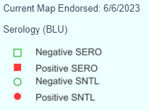
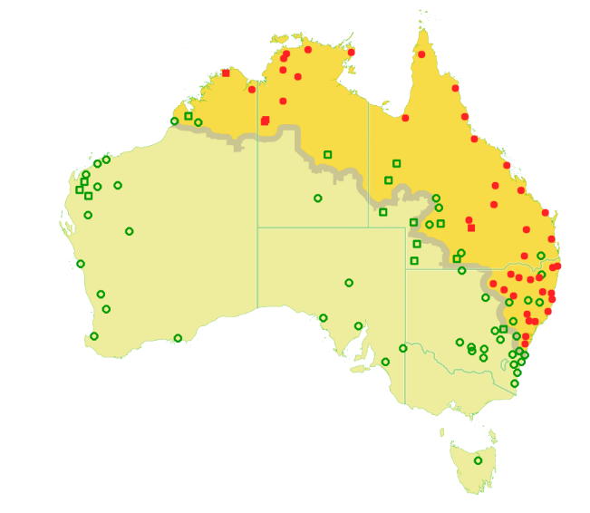

Figure 1 Serology results for NAMP cattle herds tested for bluetongue virus during the 2022–2023 arbovirus season

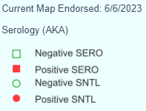
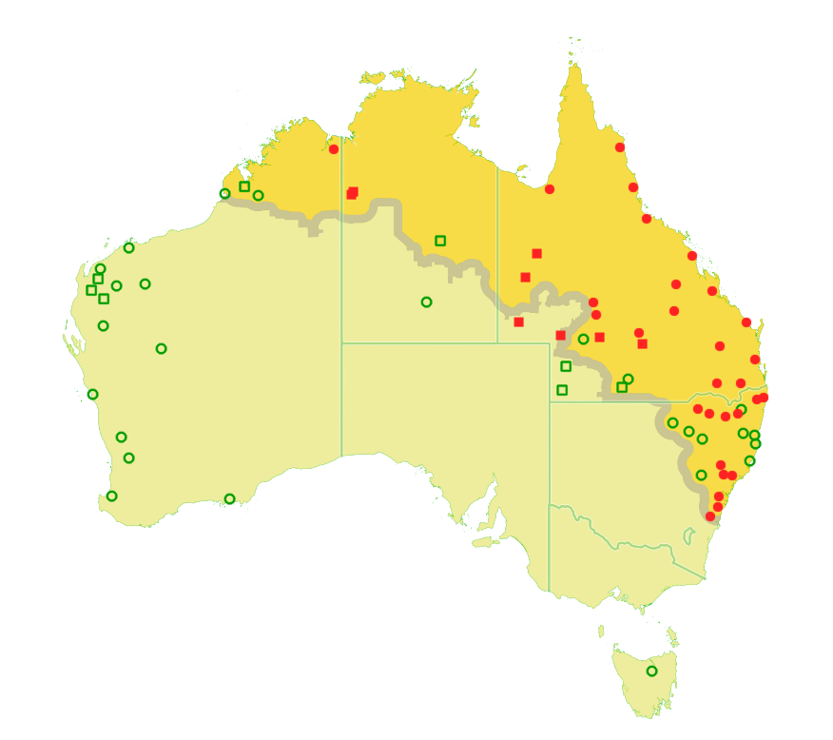
Figure 2 Serology results for NAMP cattle herds tested for Akabane virus during the 2022–2023 arbovirus season

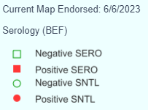
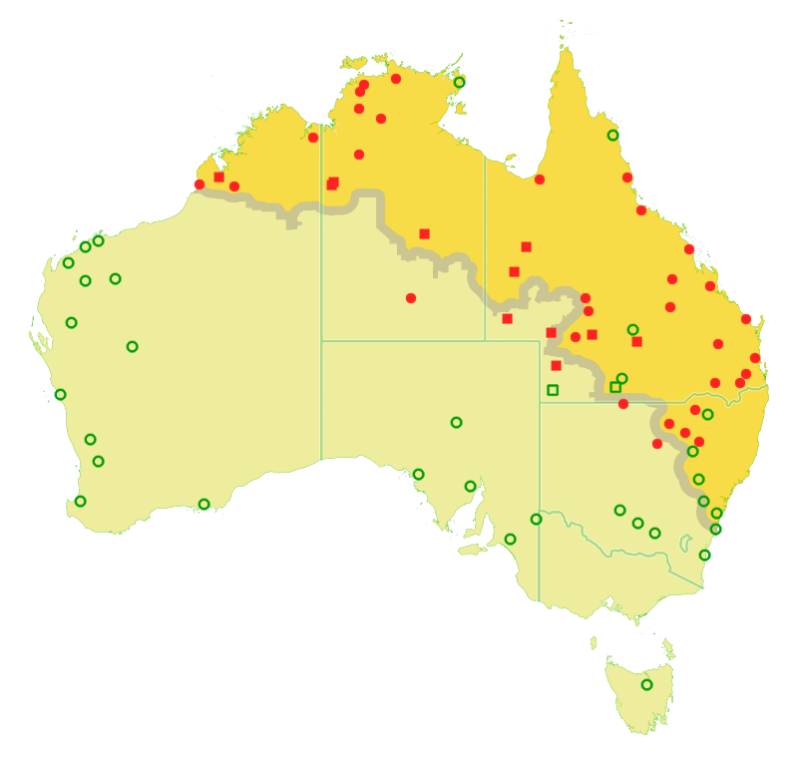
Figure 3 Serology results for NAMP cattle herds tested for bovine ephemeral fever virus, during the 2022–2023 arbovirus season. Note: Not all NAMP herds are tested for BEF, and the map only shows results from those herds tested within the NAMP.
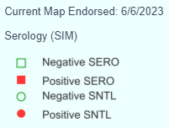
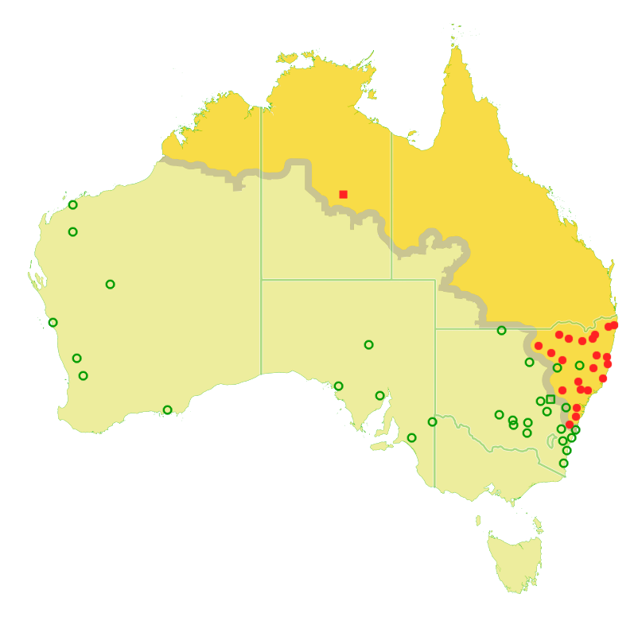
Figure 4 Serology results for NAMP cattle herds tested for Simbu group viruses, during the 2022–2023 arbovirus season. Note: Not all NAMP herds are tested for BEF, and the map only shows results from those herds tested within the NAMP.

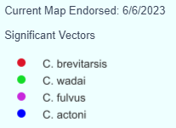
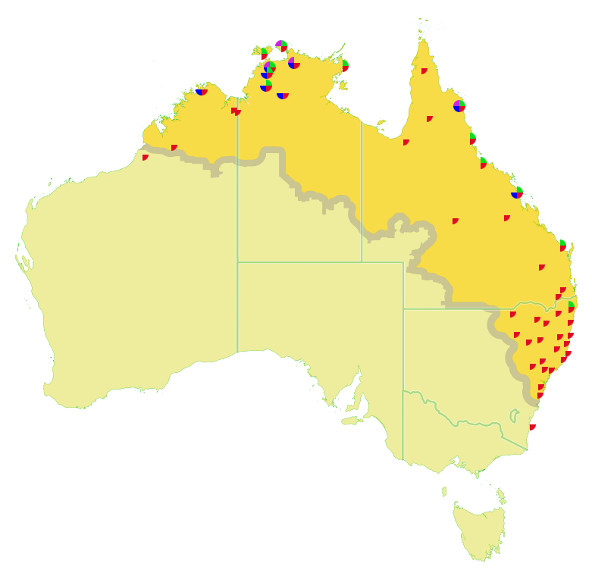
Figure 5 NAMP entomology sampling sites showing significant vectors detected through monitoring activities in the 2022–2023 arbovirus season

Activity data summary by agency: 2022-23 – DATE OF GENERATION 9 AUGUST 2023
This summary is dynamically generated from NAMP-Info and provides a summary of activities conducted in the 2022–2023 arbovirus season.

Percentage of activity reported may exceed 100% when activities undertaken at budget or replacement sites exceed those budgeted for at the beginning of the sampling year, or when data on activities for supplementary sites are included.

Serology: sentinel and serosurvey activities
Table 1 Numbers of sampling visits (listed against the agency recorded as 'collector'). Performance less than 90% highlighted.
Agency | Budgeted visits to budget sites | Visits made to official budget, replacement or additional sites | Actual visits / budgeted visits (%)
NAQS | 20 | 25 | 125
NSW GOV | 160 | 155 | 97
NT GOV | 97 | 66 | 68
QLD GOV | 103 | 71 | 69
SA GOV | 14 | 14 | 100
TAS GOV | 2 | 2 | 100
VIC GOV | 16 | 16 | 100
WA GOV | 48 | 36 | 75
Table 2 Total numbers of animals sampled (listed against the agency recorded as 'collector'). Performance less than 90% highlighted.
Agency | Animals to be sampled at budget sites | Animals sampled at official budget, replacement or additional sites | Actual samples / budgeted samples (%)
NAQS | 260 | 298 | 115
NSW GOV | 1600 | 1793 | 112
NT GOV | 1570 | 1216 | 77
QLD GOV | 1425 | 1483 | 104
SA GOV | 175 | 185 | 106
TAS GOV | 22 | 22 | 100
VIC GOV | 176 | 169 | 96
WA GOV | 780 | 596 | 76

Entomology
Table 3 Numbers of collections (listed against the agency recorded as 'farmer allowance'). Performance less than 90% highlighted.
Agency | Budgeted visits to budget sites | Visits made to official budget, replacement or additional sites | Visits made to B+R+A sites/ (budgeted visits + A visits) (%)
NAQS | 36 | 12 | 33
NSW Gov | 170 | 153 | 90
NT Gov | 84 | 46 | 55
QLD Gov | 106 | 55 | 52
SA Gov | 16 | 15 | 94
Tas Gov | 4 | 4 | 100
Vic Gov | 24 | 23 | 96
WA Gov | 124 | 42 | 34
Table 4 Numbers of collections made at non-budget sites
Location | Site type | Number of sites
NSW | ENTO | 1
NT | ENTO | 3
QLD | ENTO | 1
WA | ENTO | 1
NSW | SERO | 1
NT | SERO | 3
Qld | SERO | 3
WA | SERO | 1
NSW | SNTL | 11
SA | SNTL | 1
WA | SNTL | 1

Annual coordinator reports of NAMP monitoring 2022-23
Key recommendations and commentary of significant over and under activity will be added from coordinator annual reports on the wiki prior to circulation to the Steering Committee.

Appendix B Maps showing planned virology and entomology locations 2023–2024
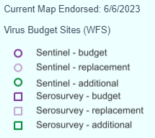
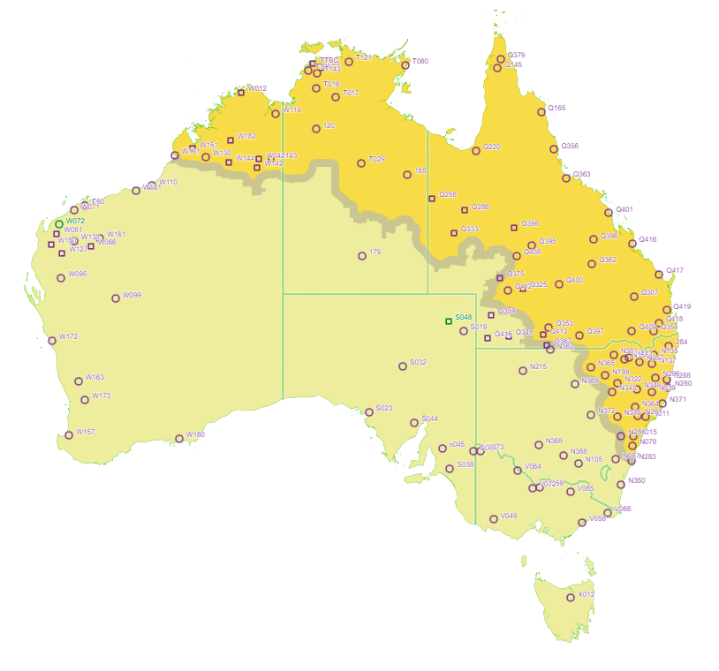
Figure 6 Map of planned virology for the 2023–2024 arbovirus transmission season.
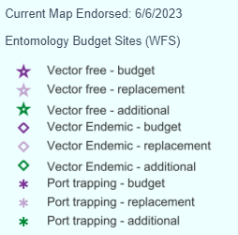
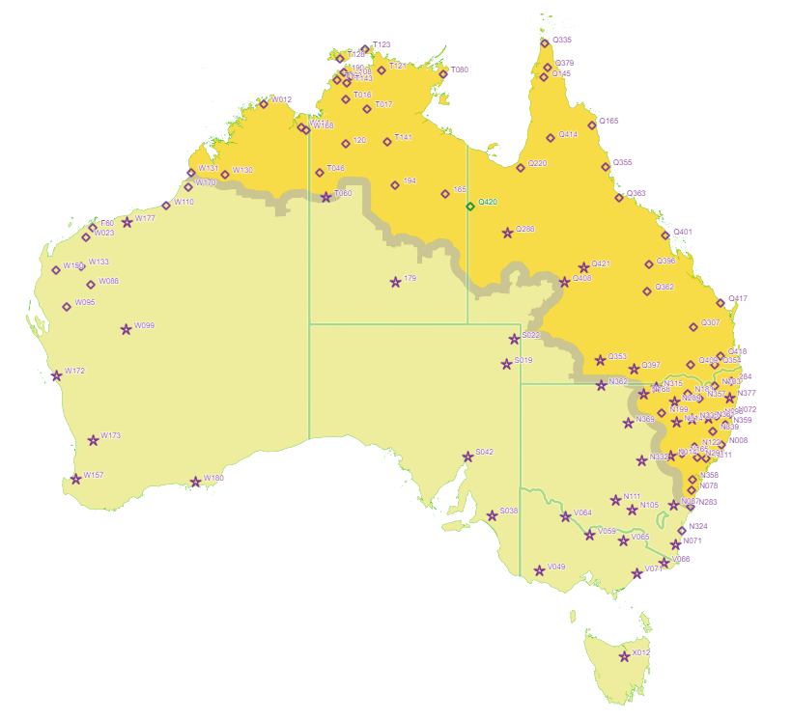
Figure 7 Map of planned entomology for the 2023–2024 arbovirus transmission season.

Appendix C: Measures of performance
Table 5 Measures of performance of NAMP during 2022–2023 by reference to agreed target outcomes and performance indicators (Business Plan 2022-23)
Target outcome  The measurable benefits that are sought from undertaking a project. | Performance indicator  The measure that will be used to indicate the level of achievement of the target outcome(s). | Measure in 2022-23  The outputs for measuring the level of performance.
Australian Government Department of Agriculture Water and the Environment (DAWE)
- Provides a technical basis for export certification for Australian livestock and germplasm to meet importing country arbovirus conditions.  - Provides a technical basis for negotiation of import health protocols for countries requiring import conditions for arboviruses.  - Provides information in support of Australia’s animal health status enabling accurate reporting to the World Organization for Animal Health (OIE).  - Support exotic disease preparedness by implementing effective surveillance systems for arboviruses. | - Bluetongue free zone accurately predicts areas where viral transmission does not occur.  - NAMP program accepted by importing countries as an effective arbovirus surveillance system.  - Records bluetongue virus types circulating in Australia, records changes in the epidemiology of bluetongue viruses observed in Australia.  - Understanding of the epidemiology of arboviruses in Australia. | - The BTV Transmission Zone boundary updated in a timely manner. There was one change to the BTV zone in the 2022–2023 arbovirus season in response to serological evidence of BTV transmission (Appendix D).  - The NAMP continued additional monitoring at 3 sites in Victoria (initiated in 2017-18) to detect if the epidemiology of bluetongue in the BTV transmission-free zone changes.  - Bluetongue virus typing occurred to determine BTV types circulating in Australia – types 1, 5, 7, 15, 16 and 21.
Livestock exporters
Satisfied information needs of livestock exporters (buyers and agents) on the distribution of bluetongue, bovine ephemeral fever and Akabane disease. | The confidence exporters have in Australian regions, reported by NAMP to be free of bluetongue, Akabane or bovine ephemeral fever i.e., the confidence exporters have to market livestock to countries concerned about Australia’s arbovirus status.  NB: some of the countries concerned about bluetongue are not actually free of this virus e.g., Israel). | - An online interactive BTV zoning map was maintained throughout 2022–2023 and was made publicly available to allow exporters to review buying areas.  - The measures listed for the DAWE also indirectly supported the needs of livestock exporters.
Livestock producers
Satisfied information needs of livestock producers on the distribution of bluetongue, bovine ephemeral fever and Akabane disease. | - The confidence livestock producers have in the zone map: temporal and spatial data points.  - The confidence livestock producers have in early detection of changes to the distribution.  - Market access to bluetongue sensitive markets maintained. | - An annual report was published in February 2023.  - A BTV transmission zone map was maintained throughout 2022–2023 and made publicly available to allow producers to make management decisions and inform them on the distribution of arboviruses.  - The measures listed for the DAWE also indirectly supported the needs of livestock producers including through maintaining market access.
State and territory governments
Satisfied information needs of state and territory governments to assess the risk of bluetongue, bovine ephemeral fever and Akabane disease occurrence and advise their stakeholders. To enable accurate property of origin certification. | - Governments have details of geographical distribution of viruses and vectors and their temporal variation.  - Governments received updates of new incursions of exotic strains of virus or exotic species of Culicoides and notification of any extraordinary epidemiological events.  - Governments have up-to-date vector map (e.g., quarterly) and incursions of new species are reported. | The measures listed above for the DAWE also supported the needs of state and territory governments in determining areas eligible for export and testing protocols required. In addition:  - A database of BEF and AKA virus occurrence was maintained throughout 2022–2023 to provide information on their distribution.  - Timely notification changes to BTV status in Australia supported the needs of state and territory governments.

Appendix D: Bluetongue virus transmission zone boundary changes 2022 – 2023 transmission season

To be updated post Technical Committee Meeting with maps and any additional changes
6/6/2023 Extension of the zone of transmission near Walgett in NSW.

Appendix E: Budget and expenditure summary
Table 7 Budget and expenditure of NAMP
Expenditure Item | Actual  2021-22 | Budget  2022-23 | Actual  2022-23 ^{c} | Budget 2023-24  (Business Plan) | Proposed Budget  2024-25  (X% CPI0F)
Program management and administration | TBA | TBA | TBA | TBA | TBA
NAMP-Info Management (database) | TBA | TBA | TBA | TBA | TBA
Entomology and virology monitoring subtotal | TBA | TBA | TBA | TBA | TBA
Contingency for Additional Monitoring (5%) | TBA | TBA | TBA | TBA | TBA
Entomology and virology monitoring total | TBA | TBA | TBA | TBA | TBA
Annual Report | TBA | TBA | TBA | TBA | TBA
Meeting Expenses | TBA | TBA | TBA | TBA | TBA
Reference Entomology | TBA | TBA | TBA | TBA | TBA
Total / Balance of Expenditure | TBA | TBA | TBA | TBA | TBA

Notes to budget and expenditure table – all figures are exclusive of GST.
a. Includes consultant fees.
b. Reference entomology is a contracted service for preparation of material for the NAMP reference collection (specimen slide mounting).
c. Figures include accruals for 2022-23.

Consistent with AHA subscriptions increase AHA Operating Plan 2023-24

